**HAPP-Assignment 2: Implementation of DP Matching**

1. **Language and Compilation**

The program is written in Python and compiled into a standalone .exe using PyInstaller.

To compile the script into .exe, run:

pyinstaller –onefile DPmatching.py

* Libraries Used: numpy, matplotlib, os

1. **How to Use**

* **Method 1: Run the Python Soutce Code**

1. Place dp_matching.py, data_a.txt, and data_b.txt in the same directory.
2. Open a terminal in the directory.
3. Run the following command: python dp_matching.py
4. The program will automatically plot and save results under a result folder.

* **Method 2: Run the Executable File**

1. Copy data_a.txt and data_b.txt to the same directory as dp_matching.exe.
2. Double-click the .exe file to execute the program.
3. **Result Details**

* After runnning, the program will:
  + Display 2 plots:
    - original signals (before matching)
    - aligned signals (after DP matching)
  + Automatically create a folder named result in the current directory
  + Save two image files inside the result folder:
    - original_signals.png
    - aligned_signals.png
* In the terminal, the program will output:
  + The total matching distance calculated by the DP Matching algorithm.
  + The number of matched points found through backtracking.
  + A sample list of matched points (A index -> B index).

1. **Result Capture**

* Screenshots showing the program execution can be found in the result_capture/ folder.
* Original Signals

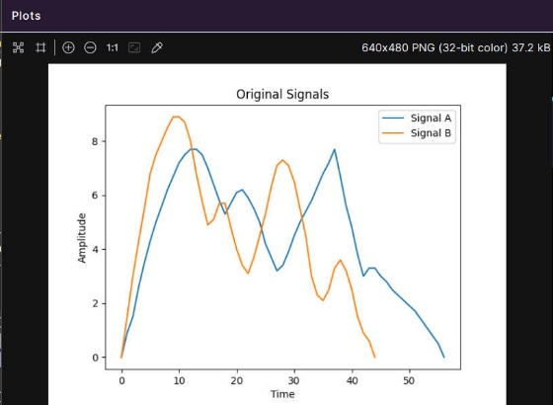

* Aligned Signals

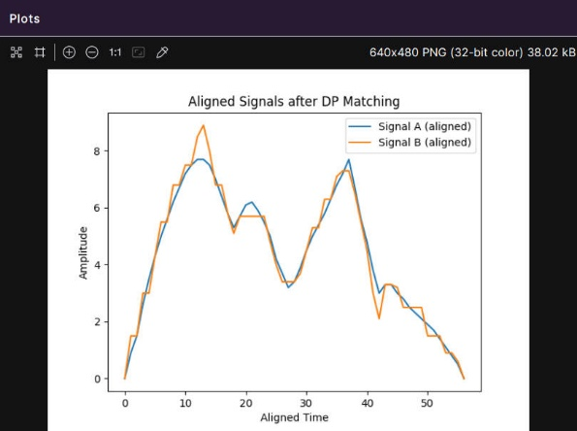

* DP Matching

